**Class 1 :**

Q.1 Study Oozie components in details, For reference follow the link http://oozie.apache.org/docs/4.3.0/index.html

Q.2 Try out below commands and see the impact :

a. moveToLocal



b. touchz

created 0 byte file but doesn’t throw error if we recreate, it does nothing

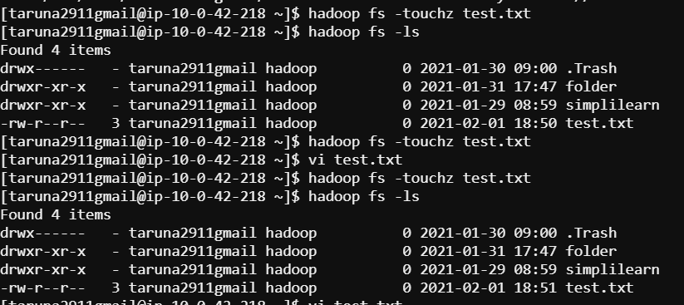

c. moveFromLocal



d. copyFromLocal



e. appendToFile

not working ,generally unsuported

f. getfattr

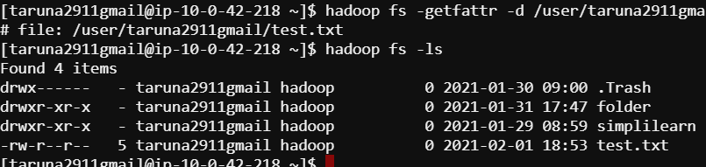

g. setrep

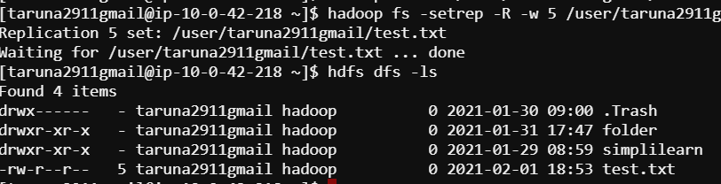

h. getmerge

no file found in destination loc



Q.3 What is check pointing in HDFS ? (https://blog.cloudera.com/blog/2014/03/a-guide-to-checkpointing-in-hadoop/)

Q.4 Secondary name node myths and truths

. (<http://blog.cloudera.com/blog/2009/02/multi-host-secondarynamenode-configuration/>)

Q.5 How Hadoop determined the distance between two nodes?

Q.6 What is the role ContainerLaunchContext class in executing Application?